**Розвиток граматичних навичок учнів.**

*13.04.2022 8А, 8Б Хоменко А.Ю.*

*Procedure*

**Grammar practice.**

1. **Writing.(вставте прийменники правильно**)

Put in the correct prepositions.

The center (1) ... London has many different areas. Covent Garden (2) ... London’s West End, is crowded (3) ... cafes, clubs and clothes shops. Soho is also known (4) ... its clubs. Knightsbridge has a lot of exclusive shops, as well as many (5) ... the embassies. Fleet Street is the home (6) ... the Law Courts. Oxford Street is London’s main shopping street (7)... the heart of the West End.

When you go outside the center, you find many areas which used (8)... be small villages. The villages became part (9) ... the city, but they still managed to keep their village character. Hampstead, the best-known (10) ... them, is extremely expensive. Next (11) ... Hampstead Village there is Hampstead Heath, a huge park (12)... open countryside, lakes, trees and bathing pools.

1. ***Writing. Answer the question in Past Simple***

1. When did you go to the theatre last time?

2. Where did you go?

3. What did you see?

4. When did the performance start?

5. Did you sit far from the stage?

6. How much did the ticket cost?

7. Did you like the performance?

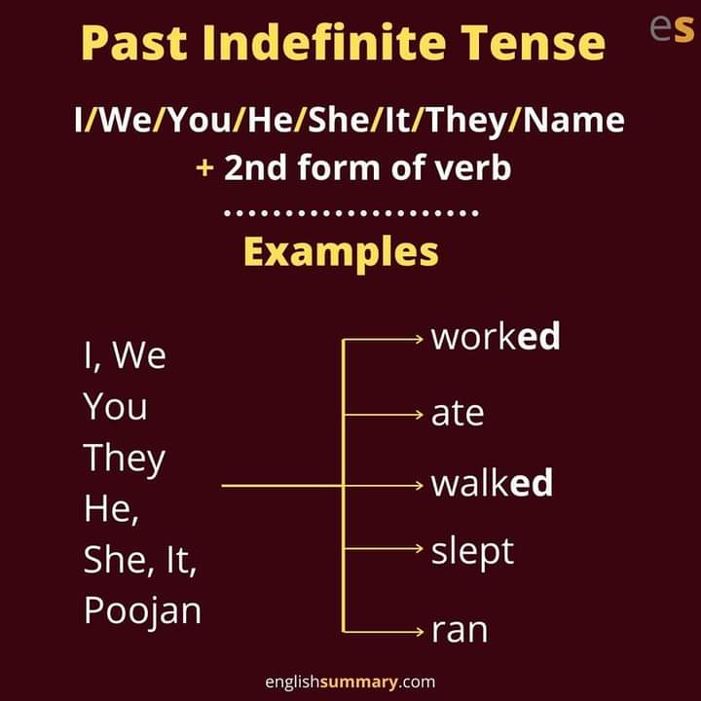

**Home work**: Шановні діти, потренуємося виконуючи вправи з граматики. Вашим завданням буде:

* виконання вправи в конспекті письмово, там треба правильно вставити прийменники
* відповісти на питання в Past Simple після тексту усно. Гарного дня)))